**DEPARTMENT OF MATHEMATICS**

**PROJECT RECORD**

**ON**

**EXPLORING WORLD TOP MOST YOUTUBE CHANNEL**

**FUNDAMENTAL OF DATA ANALYTICS WITH TABLEAU**

**2023-2024**

**TAMILNADU SKILL DEVELOPMENT CORPORATION, GOVERNMENT OF TAMILNADU,**

**NAAN MUDHALVAN PROGRAM**

**Submitted**

**By**

**1.vijayadharshini.R (2222…)**

**2.Nuzath farheen. H**

**3. Hemavathi. K**

**4.Dhanalashkmi.p**

**(III B.Sc MATHEMATICS)**

**CERTIFICATE**

**THIS IS TO CERTIFY THAT THE PROJECT IS TITLED UNEARTHING THE ENVIRONMENTAL IMPACT OF HUMAN ACTIVITY: A GLOBAL CO2 EMISSION ANALYSIS- FUNDAMENTALS OF DATA ANALYTICS WITH TABLEAU.**

**THIS PROJECT IS SUBMITTED BY A.KASTHURI (222…), K.MANAGALADEEPA(222…),………… OF III B.SC MATHEMATICS, Dr.MGR JANAKI COLLEGE OF ARTS AND SCIENCE FOR WOMEN, CHENNAI IN FULFILLMENT OF THE REQUIREMENTS FOR TAMILNADU SKILL DEVELOPMENT CORPORATION, GOVERNMENT OF TAMILNADU,NAAN MUDHALVAN PROGRAM. THIS PROJECT WAS AN AUTHENTIC WORK DONE BY HIM UNDER MY SUPERVISION AND GUIDANCE.**

**TABLE OF CONTENTS**

|  |  |  |
| --- | --- | --- |
| **S. NO** | **CONTENTS** | **PAGE NUMBER** |
| **1** | **INTRODUCTION** | **1** |
|  | 1.1 OVERVIEW | **1** |
|  | 1.2 PURPOSE | **2** |
| **2** | **PROBLEM DEFINITION &DESIGN THINKING** | **2** |
|  | 2.1EMPATHY MAP | **3** |
|  | 2.2 IDEATION &BRAIN STORMING MAP | **3** |
| **3** | **RESULTS** | **4** |
| **4** | **VIDEO** | **7** |
| **5** | **ADVANTAGE &DISVANTAGE** |  |
|  | 5.1 ADVANTAGE | **7** |
|  | 5.2DISVANTAGE | **7** |
| **6** | **APPLICATIONS** | **7** |
| **7** | **CONCLUSION** | **7** |
| **8** | **FUTURE SCOPE** | **8** |
| **9** | **REFERENCE** | **9** |

**INDIA’S AGRICULTURAL CROP PRODUCTION ANALYSIS (1997_2021)**

**Activity: India’s agricultural crop production Analysis**

**1.INTRODUCTION**

**1.1 OVERVIEW:**

This report delves into the captivating realm of India’s agricultural cultivation, Providing a comprehensive visual exploration of key aspects and trends in the agricultural sector. Through the visual representations, readers can gain valuable insights into crop production, seasonal variations, regional distribution, and overall production trends. These visualizations enable intuitive analysis, allowing stakeholders to uncover patterns, identify areas of growth or concern, and make data-driven decisions.

By harnessing the power of Tableau, this report not only presents the data in a visually appealing manner but also provides an interactive experience for readers to explore the intricacies of India’s agricultural cultivation. To Extract the Insights from the data and put the data in the form of visualizations, dashboards and Story we employed Tableau tool.

**1.2 PURPOSE:**

This visualisation in tableau enables users to create hierarchies using data fields given for agricultural production analysis for India, which makes it easy to break down the visualization and organize data in a logical order for convenience of the viewer.

**2.PROBLEM DEFINITION &DESIGN THINKING**

**2.1 EMPATHY MAP:**

Using an empathy map we provide acollaborative visualization to articulate what we know about a particular type of user. This map externalizes knowledge about users in order to 1) create a shared understanding of user needs, and 2) aid in decision making. Print out or sketch the empathy map template on a large piece of paper or whiteboard. Hand each team member sticky notes and a marker. Each person should write down their thoughts on stickies. Ideally everyone would add at least one sticky to every section. You might ask questions, such as:

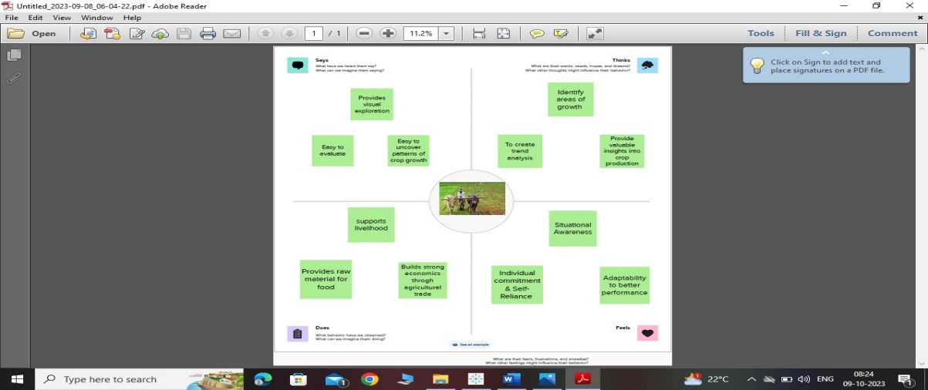

**2.1 IDEATION & BRAINSTORMING MAP:**

Brainstorming is a method of generating ideas and sharing knowledge to solve a particular commercial or technical problem, in which participants are encouraged to think without interruption. Brainstorming is a group activity where each participant shares their ideas as soon as they come to mind. At the conclusion of the session, ideas are categorised and ranked for follow-on action.When planning a brainstorming session it is important to define clearly the topic to be addressed. A topic which is too specific can constrict thinking, while an ill-defined topic will not generate enough directly applicable ideas. The composition of the brainstorming group is important too. It should include people linked directly with the subject as well as those who can contribute novel and unexpected ideas. It can comprise staff from inside or outside the organisation.

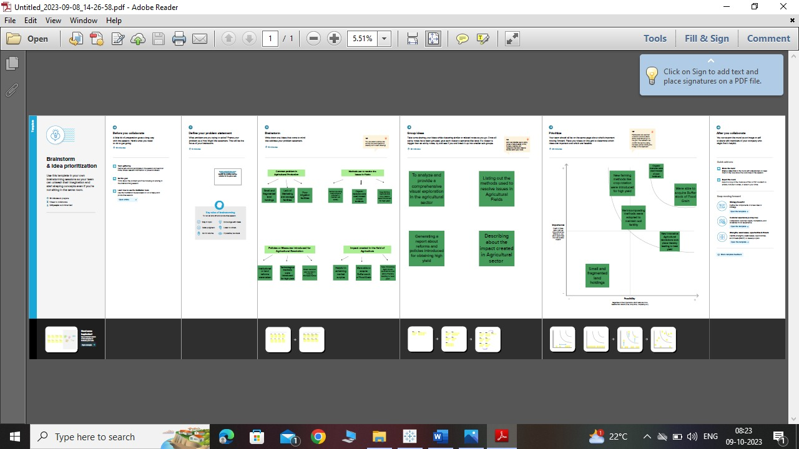

**3.RESULT:**

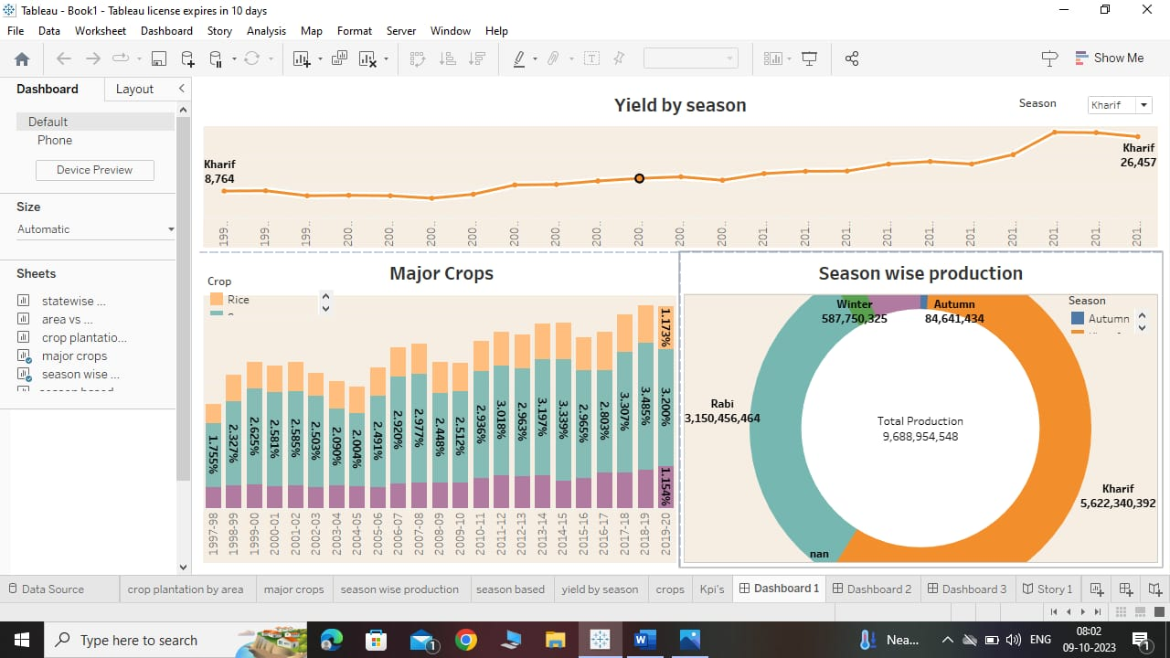

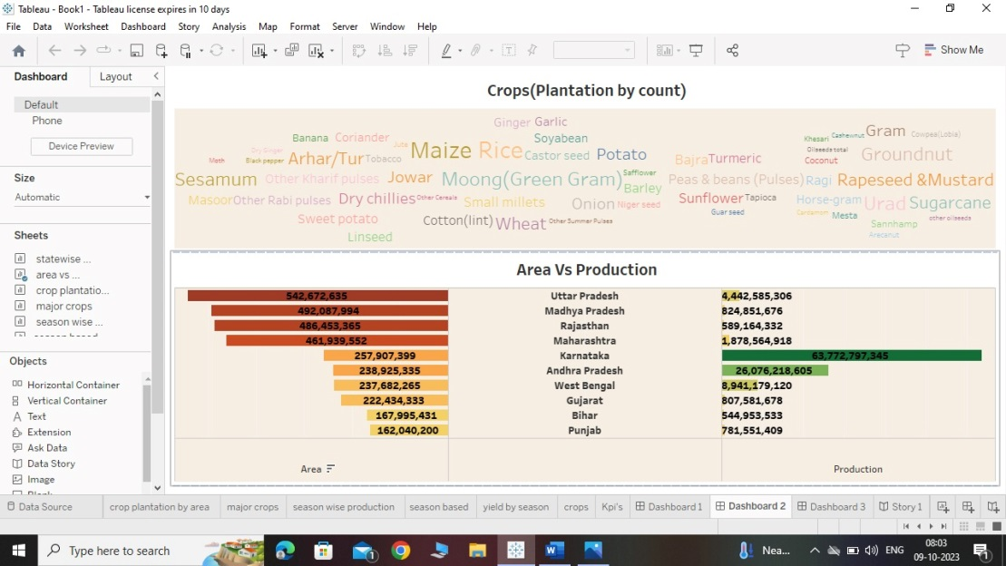

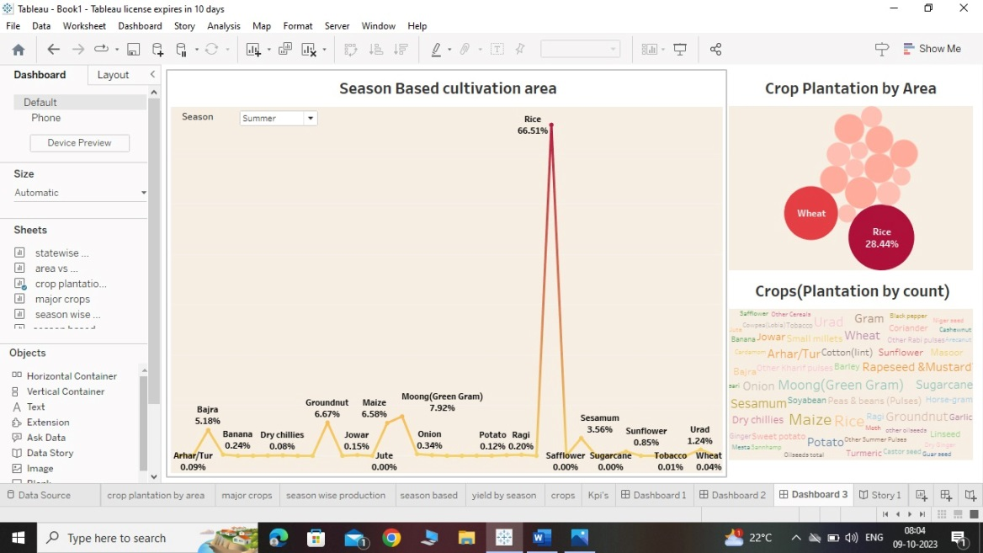

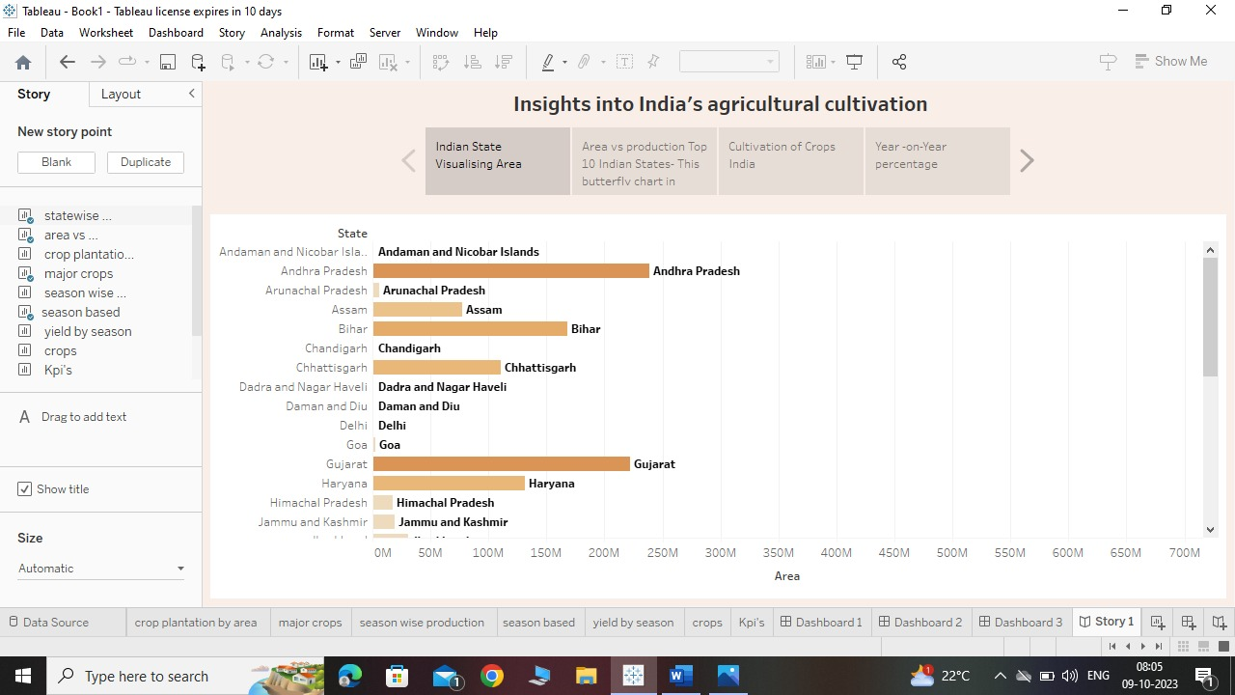

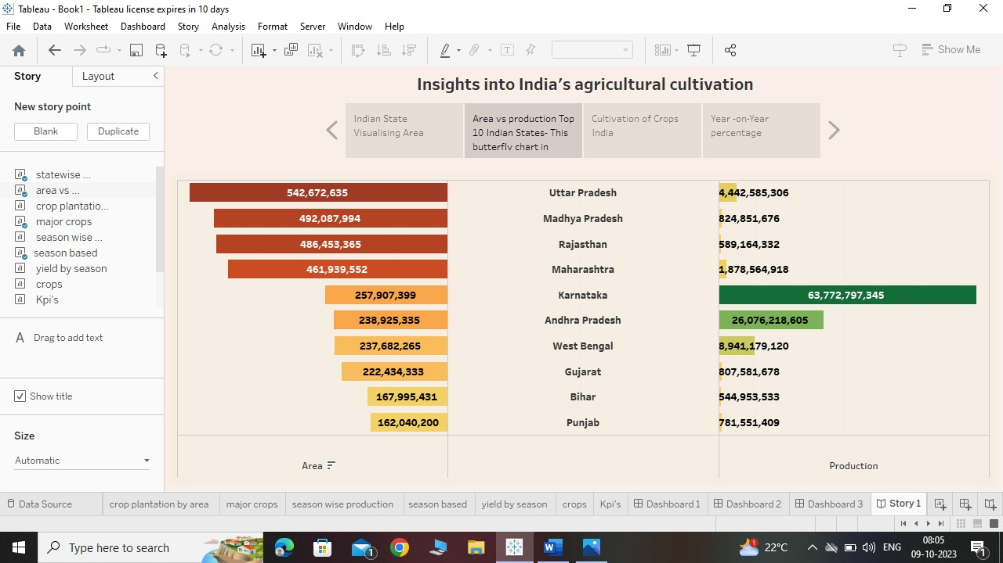

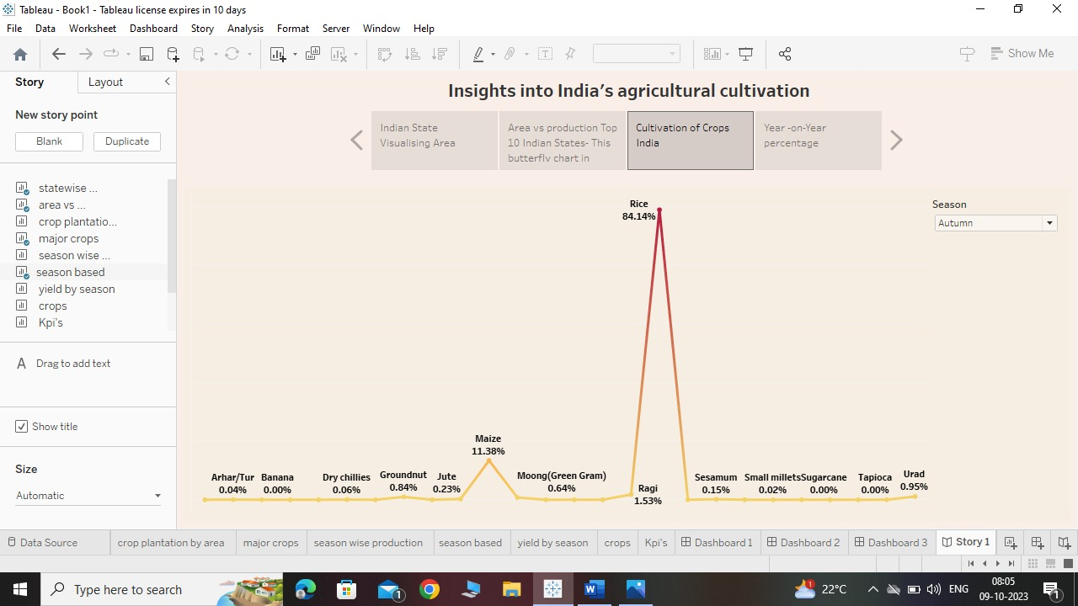

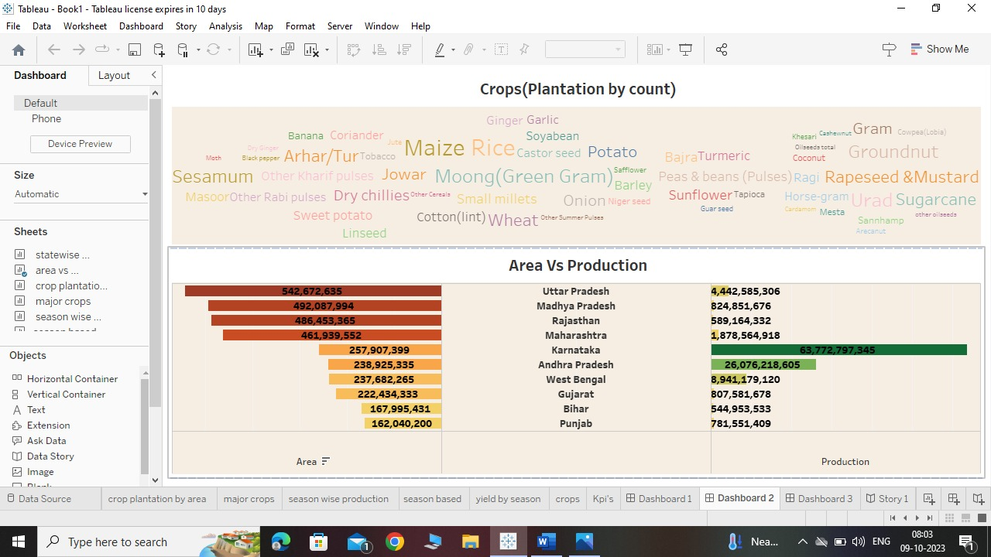

**4 VIDEO:**

[**https://drive.google.com/file/d/1KFzCKno5GOVNBgyt9Yt-ENBBCwS8S-Jz/view?usp=drivesdk**](https://drive.google.com/file/d/1KFzCKno5GOVNBgyt9Yt-ENBBCwS8S-Jz/view?usp=drivesdk)

**5.ADVANTAGES & DISADVANTAGES:**

5.1: India’s agricultural crop production Analysis:

It can be seen that a simple visualization has unfolded many hidden facts. Wheat, rice, and sugarcane are the three consistent largest produced crops over the years. Not only has this quick visualization uncovered some good insights, it also has paved way for the next set of questions which come to an analytical mind.

**5.2 Advantages:**

Flexibility and Versatility is a great advantage of visualizing using this software as it helps us connecting to a wide range of data sources, from spreadsheets and databases to cloud services and web applications. It also enables us to blend and join data from different sources to create a comprehensive and holistic view of our data. Tableau supports various types of visualization, such as bar charts, line charts, pie charts, scatter plots, heat maps, tree maps, histograms, and more. We can also create interactive dashboards that allows us to filter, sort, highlight, and drill down into our data. Tableau is a powerful and scalable data visualization tool that can handle large and complex data sets with ease.

**5.3. Disadvantages :**

The main disadvantage of using Tableau is for visualising this data is, only recent versions supports revision history and for the older one's package rolling back is not possible. We don’t get an automatic option to refresh our reports with the help of scheduling. Therefore, some manual effort required to update the data in back-end. Even if the Tableau Software is easy to use for BI application, still it doesn’t provide any platform for developing analytic applications that can be widely shared.

**6.APPLICATIONS:**

Visualising the datain agriculture are diverse, from precision farming to livestock management. Perhaps one of the most promising applications is in the area of precision farming. By collecting data on factors such as weather, soil conditions, and plant growth, farmers can better understand how to optimize their crop yields.The information collected can be used by farmers to make more efficient use of their land and by agronomists to better understand the needs of crops. This helps the farmers to predict weather patterns and forecast crop yields with increasing accuracy. In the past, farmers would make decisions based on their experience and intuition about the weather. However, this approach is often inaccurate, leading to poor crop yields and financial losses. One of the most important applications is in disease detection and pest management. By analyzing data on crop growth, climate, and soil conditions, we can develop models that can predict when and where diseases are likely to occur. This information can then be used to develop targeted pest management strategies that can minimize crop damage. Additionally, by analyzing large data sets on historical crop yields, we can help farmers to optimize their planting and harvesting schedules to maximize yields.

**7.CONCLUSION:**

Using this visualisation from tableau we have the potential to revolutionize the agricultural industry. Farmers have been collecting data about their crops for centuries, but only recently have they had the tools to make sense of this data. With the help of this type of data visualisation tools , farmers can gain a deeper understanding of their crops and make more informed decisions about how to care for them by harnessing the power of Analytics.

In addition, this can help farmers to identify patterns and trends that may not be immediately apparent. With its ability to collect and analyze vast amounts of data, this has the potential to transform the way we farm and dramatically improve the efficiency of agriculture.

**8.FUTURE SCOPE:**

. Tableau Is The Future of Data Analytics in all stream including Indian agriculture as it can help the nation tackle three of its biggest challenges — feeding a huge and expanding population, ensuring sufficient energy supplies and curbing emissions. Still, meeting these goals will require a coordinated effort with alignment across policy, investment and agricultural research. The study found that precision agriculture technologies, such as GPS mapping and sensor networks can increase crop yields by up to 30%.In addition to precision agriculture, Big Data is also being used to improve supply chain management in agriculture. By tracking the movement of crops from the field to the supermarket, farmers can identify inefficiencies in the supply chain and reduce waste. For example, Walmart is using blockchain technology to track the movement of produce from the farm to the store, which has led to significant reductions in waste and improved food safety.

**9.REFERENCE:**

Abhisek. (2018, July 18). Crop production statistics in India (1997-2014). Retrieved August 8 2021, from <https://www.kaggle.com/abhiseklewan/crop-production-statistics-from-1997-in-india>a

Lytos, A., Lagkas, T., Sarigiannidis, P., Zervakis, M., & Livanos, G. (2020). Towards smart farming: Systems, frameworks and exploitation of multiple sources. Computer Networks, 172, 107147.

Coble, K. H., Mishra, A. K., Ferrell, S., & Griffin, T. (2018). Big data in agriculture: A challenge for the future. Applied Economic Perspectives and Policy, 40(1), 79-96.